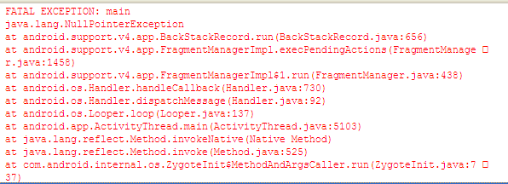
问题描述：
java.lang.NullPointerException
at android.support.v4.app.BackStackRecord.run(BackStackRecord.java:656)
at android.support.v4.app.FragmentManagerImpl.execPendingActions(FragmentManager.java:1458)
at android.support.v4.app.FragmentManagerImpl$1.run(FragmentManager.java:438)
解决方法：
@Override
public boolean onKeyDown(int keyCode, KeyEvent event) {
Log.d(BaseApplication.TAG, getClass()+"running onKeyDown()");
if (keyCode == event.KEYCODE_BACK) {
if (!this.isDestroyed())
destroyAllFragment();
finish();//添加此句解决问题
return true;
}
return super.onKeyDown(keyCode, event);
}

